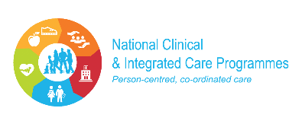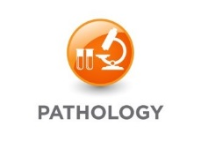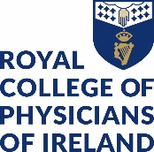

NATIONAL LABORATORY HANDBOOK
CONSULTATION FEEDBACK FORM

The National Clinical Programme for Pathology is in the process of producing the next ten guidelines of the National Pathology Handbook. The aim of the Handbook is to provide a set of concise national guidelines and order sets for common clinical diagnostic problems particularly those which were associated with either high volumes or potential over-usage of laboratory medicine investigations.

In line with the Clinical Programme and Strategy Division’s standard process for the development of a guideline the National Clinical Programme for Pathology would like to consult with all appropriate bodies.

We would like you to document feedback on the attached guideline using the template below and return it to joanmccormack@rcpi.ie

Name of guideline reviewed
Your comments

Your name
Date
Contact details
Organisation

